Agile in Jira (Scrum & Kanban Workflows)

1. Scrum Workflow in Jira: Sprints, Planning, and Execution
Scrum is an Agile framework used to deliver work in fixed-length iterations called sprints.
Scrum Workflow in Jira
Product Backlog → Sprint Planning → Sprint Execution → Review → Done
Key Scrum Components in Jira
- Product Backlog – All user stories and tasks
- Sprint – Time-boxed iteration (1–2 weeks)
- Sprint Planning – Selecting work for the sprint
- Sprint Board – Visual tracking of sprint work

Hands-On Lab: Create and Run a Sprint
- Open Scrum Project
- Go to Backlog
- Click Create Sprint
- Drag issues into sprint
- Click Start Sprint
- Set duration (7 or 14 days)
- Move issues across:
  - To Do → In Progress → Done
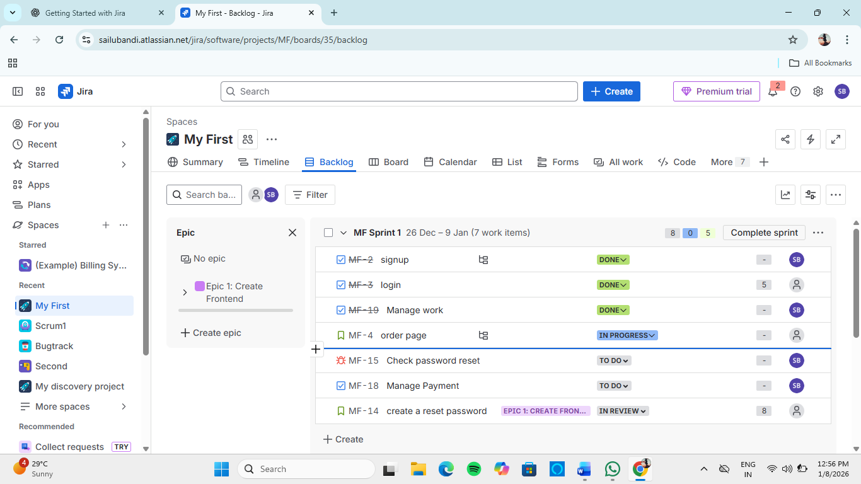
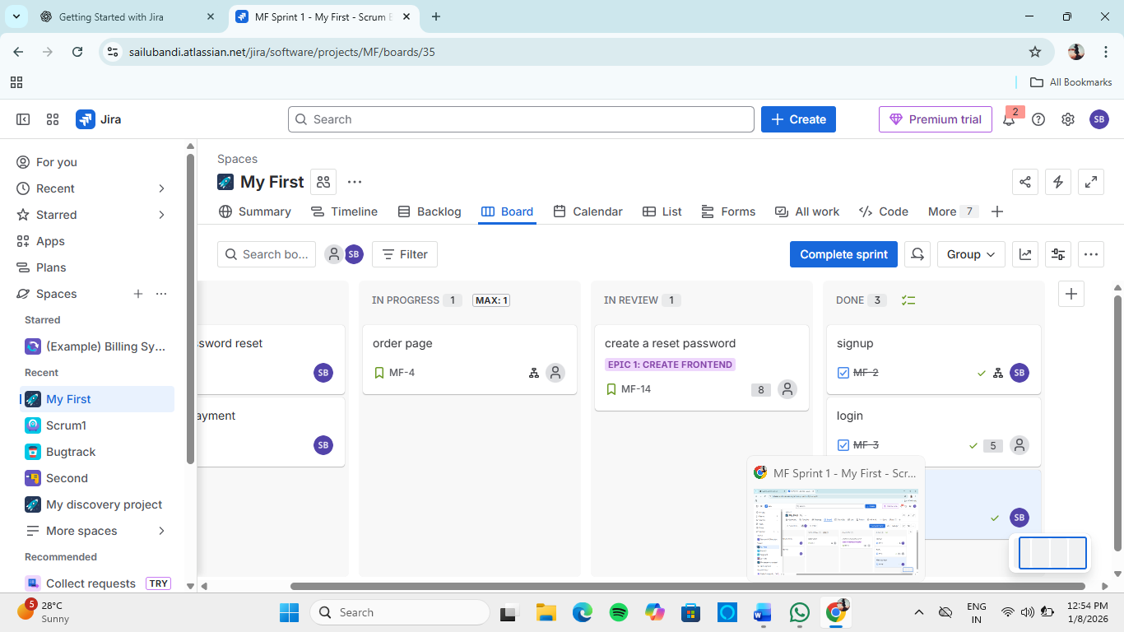

2. Estimating with Story Points and Time in Agile Projects
Estimation helps teams predict effort and plan capacity.
2.1 Story Points
- Measure relative effort, not time
- Based on:
  - Complexity
  - Risk
  - Effort
- Common scale: 1, 2, 3, 5, 8, 13
Example:
- Login page → 3 points
- Payment module → 8 points

2.2 Time-Based Estimation
- Uses hours/days
- Best for operational or support tasks
Fields in Jira:
- Original Estimate
- Remaining Estimate
- Time Spent

Hands-On Lab: Add Estimation
- Open an issue
- Click Estimate
- Enter:
  - Story Points (Scrum)
  - OR Time Estimate (hours)
- Save changes

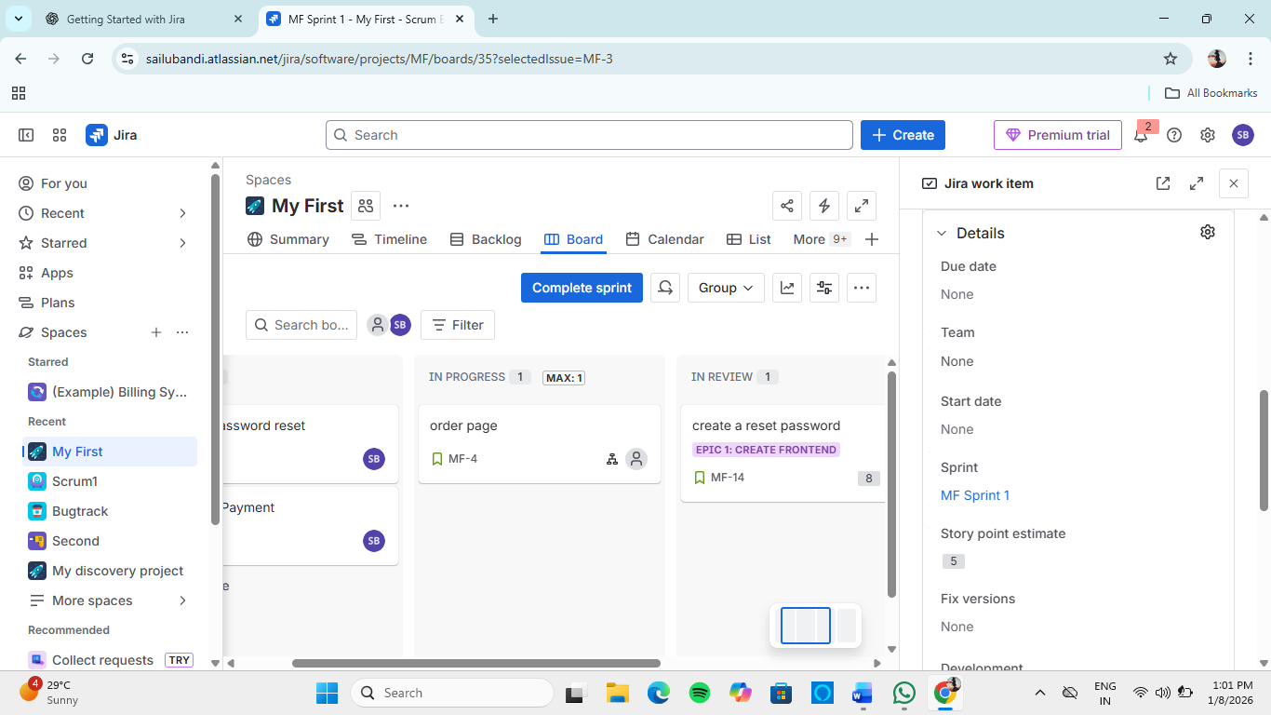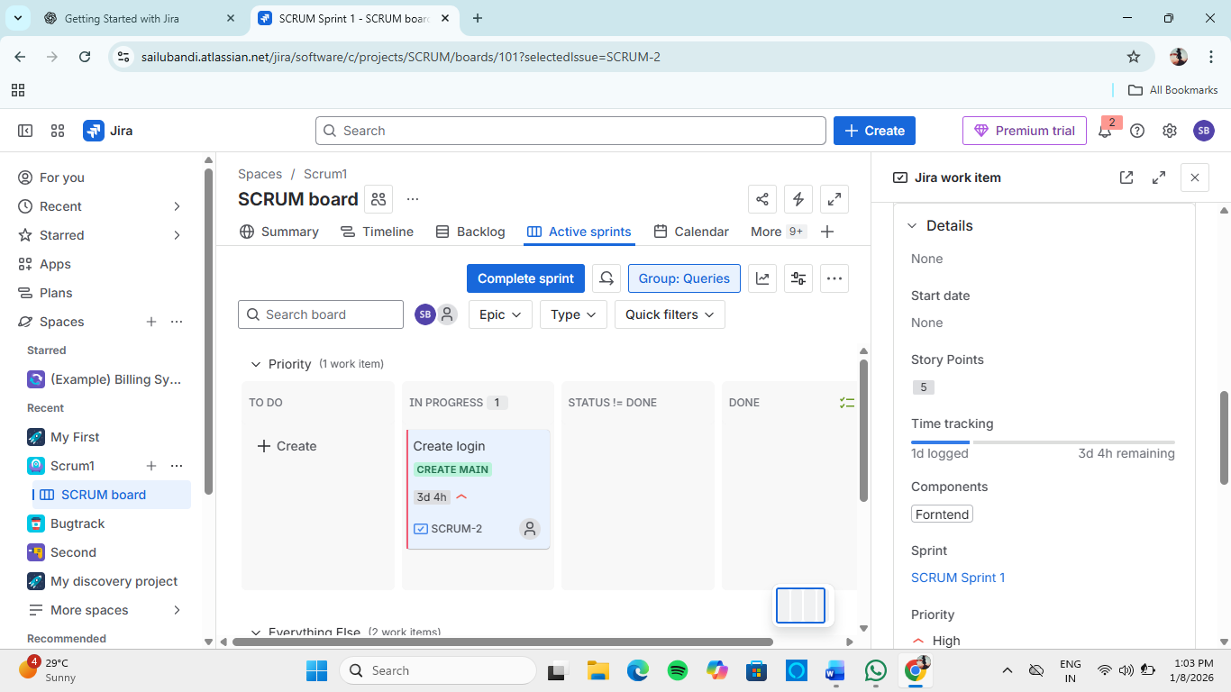
3. Running Daily Standups with Jira: Best Practices
A Daily Standup is a short (15 min) meeting to synchronize the team.
Standup Questions
- What did I complete yesterday?
- What will I work on today?
- Any blockers?

Using Jira for Daily Standups
- Use Active Sprint Board
- Filter by:
  - Assignee = Current User
- Update issue status before meeting
- Add comments for blockers

Best Practices
✔ Update Jira before standup
✔ Keep issues small and clear
✔ Use comments instead of long discussions
✔ Track blockers visibly

4. Working with Kanban: Managing Flow Over Time in Jira
Kanban focuses on continuous delivery and smooth workflow, not sprints.
Kanban Principles
- Visualize work
- Limit work in progress
- Manage flow
- Improve continuously

Kanban Workflow Example
Backlog → To Do → In Progress → Review → Done

Hands-On Lab: Kanban Board
- Create Kanban Project
- Add issues
- Move issues across columns
- Observe cycle time and flow
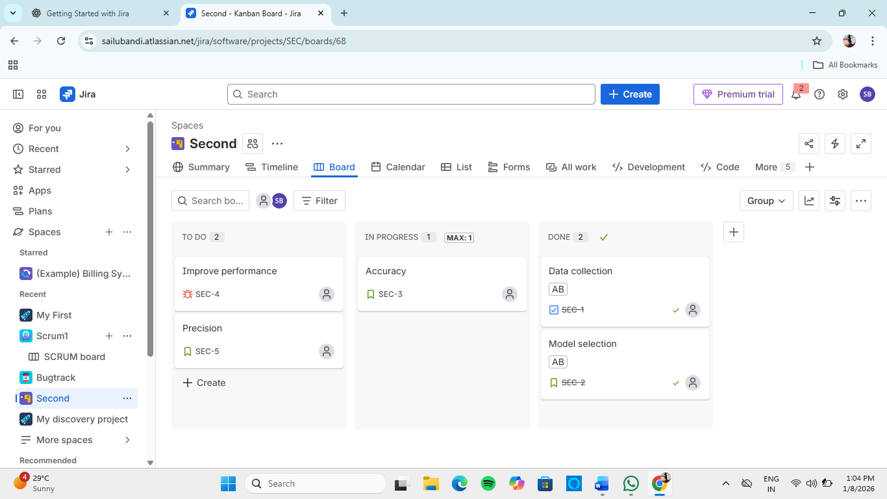

5. Visualizing Work with WIP Limits and Swimlanes
5.1 WIP (Work In Progress) Limits
- Restrict number of issues per column
- Prevent overloading team
Example:
- In Progress → WIP limit = 3

Hands-On: Set WIP Limits
- Go to Board Settings
- Select Columns
- Set WIP limit for columns
- Save
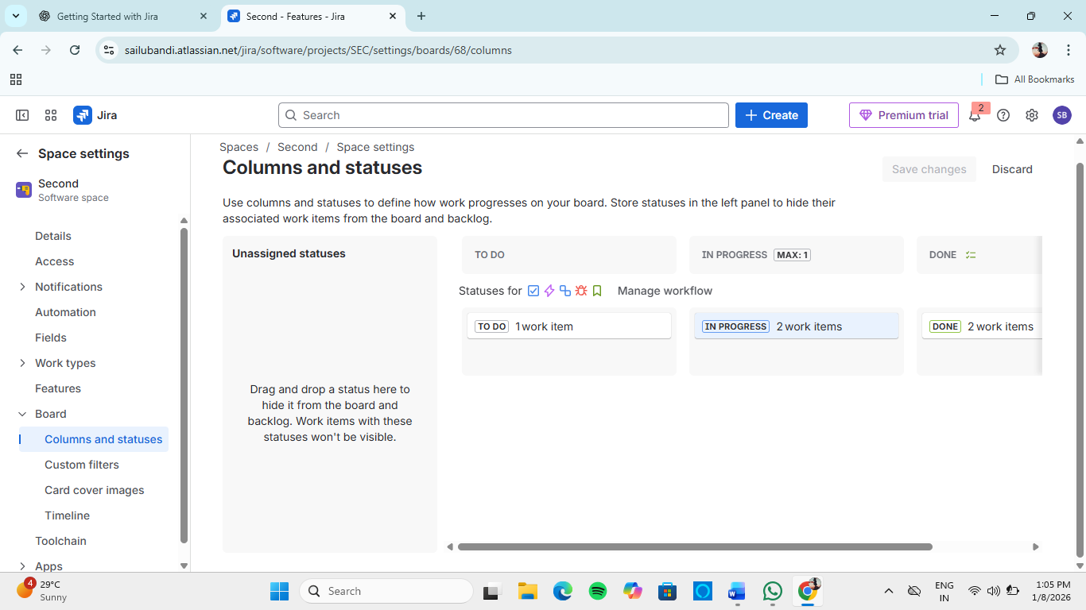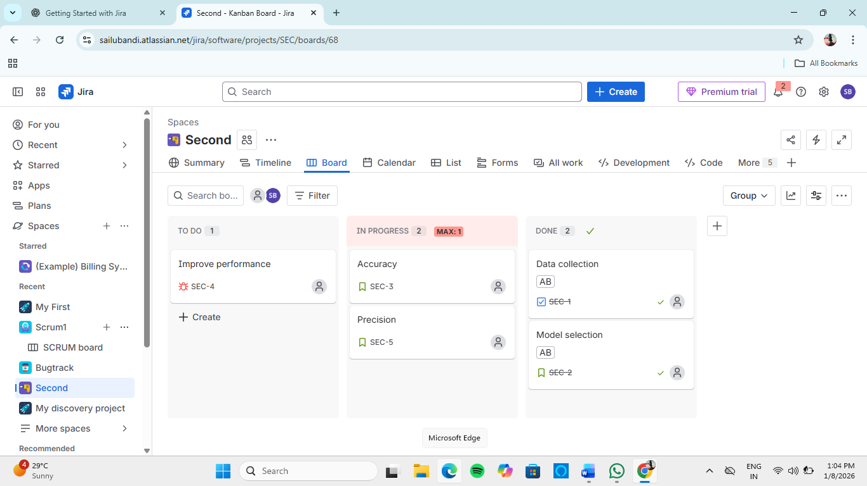

5.2 Swimlanes
Swimlanes group issues visually on the board.
Common Swimlanes:
- By Assignee
- By Priority
- By Epic

Hands-On: Configure Swimlanes
- Open Board Settings
- Select Swimlanes
- Choose grouping option
- Apply changes
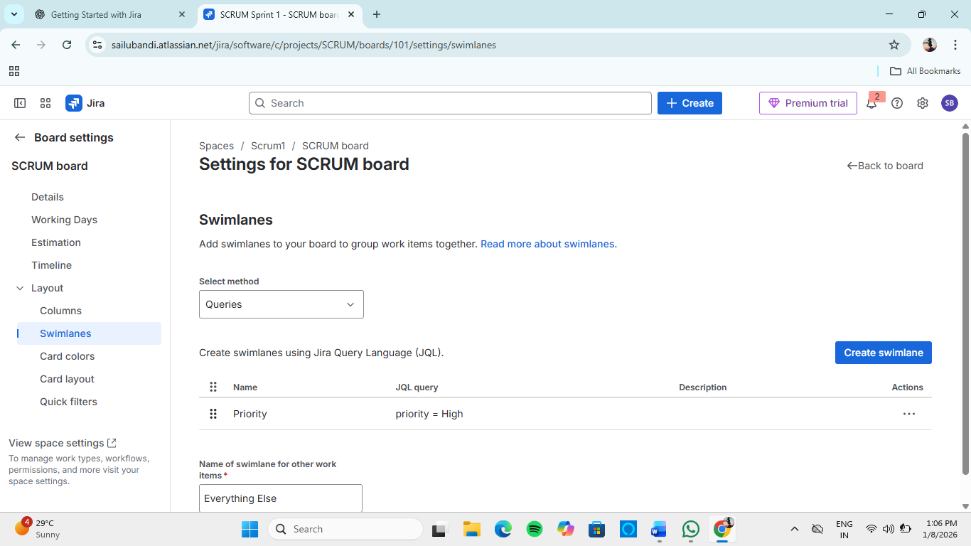
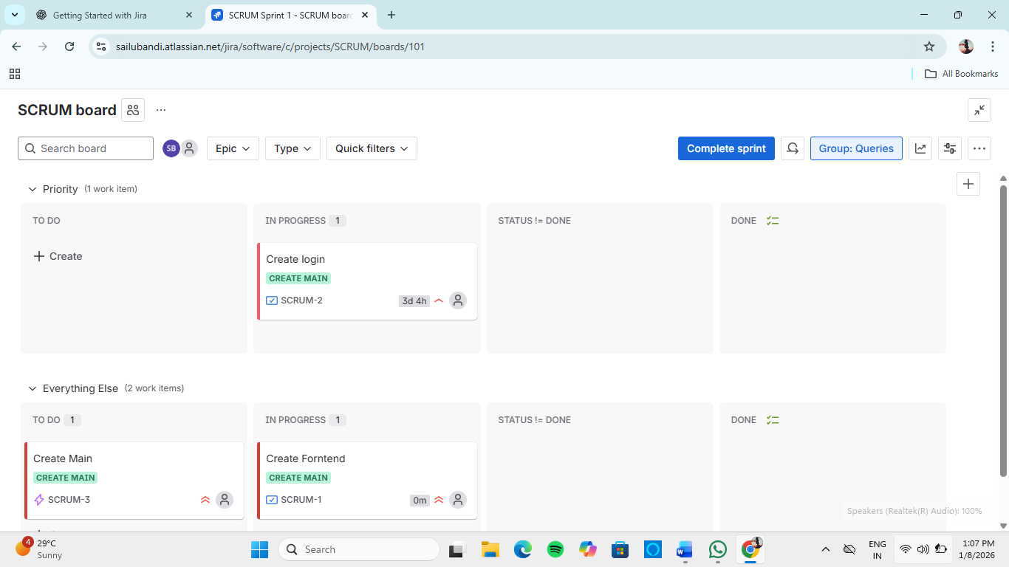

6. Understanding the Cumulative Flow Diagram (CFD)
The Cumulative Flow Diagram is a Kanban report used to analyze workflow stability and bottlenecks.
What CFD Shows
- Work distribution over time
- Bottlenecks in workflow
- Delivery consistency

How to Read CFD
- Smooth parallel lines → Healthy workflow
- Widening band → Bottleneck
- Steep Done line → High throughput

Hands-On: View CFD
- Open Kanban Project
- Go to Reports
- Select Cumulative Flow Diagram
- Analyze trends
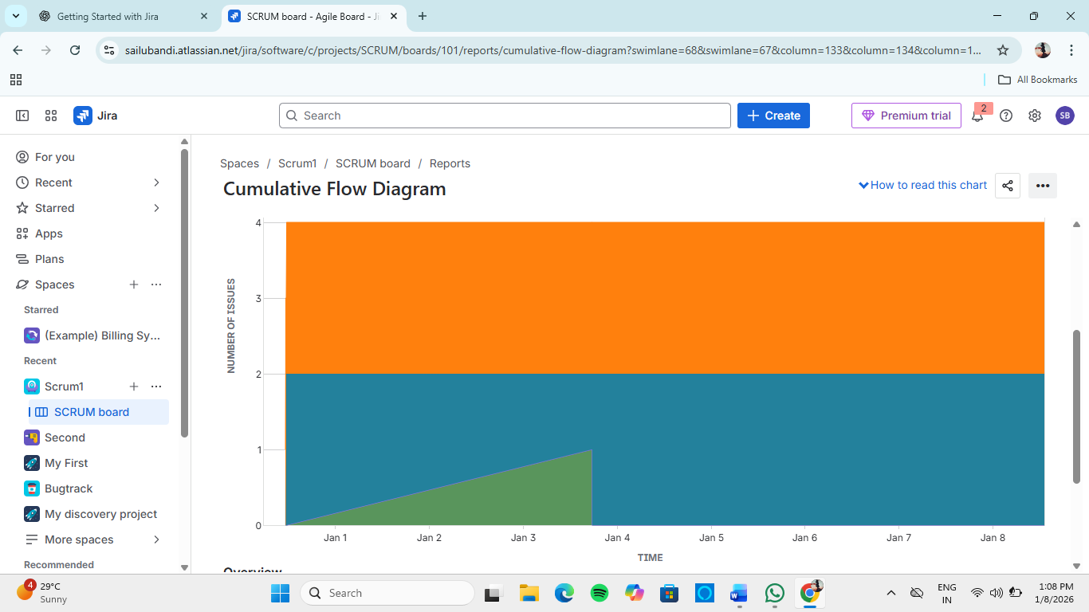

7. Scrum vs Kanban (Quick Comparison)
Feature | Scrum | Kanban
Iterations | Fixed sprints | Continuous
Roles | Scrum Master, PO | No fixed roles
Planning | Sprint-based | On-demand
Metrics | Velocity, Burndown | Cycle Time, CFD

8. Learning Outcomes
After this module, the learner can:
- Execute Scrum workflows using Jira
- Estimate work using story points
- Conduct daily standups with Jira boards
- Manage Kanban flow effectively
- Apply WIP limits and swimlanes
- Analyze performance using CFD

